***EDF Scheduler***

**Task parameters :**

1. **Task1 : {p:1 , P:5ms ,E:0.15ms ,D:5ms}**
2. **Task2 : {p:1, P:20ms: ,E:15ms ,D:15ms}**

**System tick rate :**

* **Sys Tick = 1 ms**

**Calculation of hyperperiod and CPU LOAD :**

* **Hyperperiod = 100ms**
* **CPU LOAD = 78 %**

**the system in Simso and verify that your design is schedulable :**

* **Gentt Chart :**

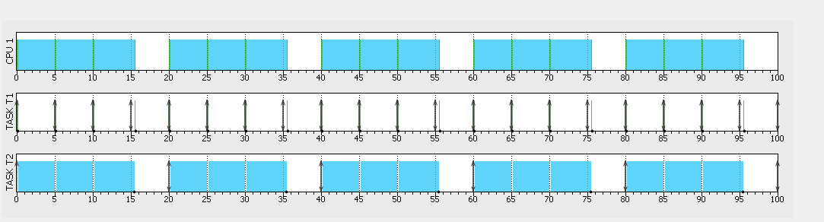

* **Results :**

***Run Time Analysis :***

* **Execution Time of Tasks :** 
  + **PIN 0 🡪 tick interrupt**
  + **PIN 1 🡪 Task1 tracing**
  + **PIN 2 🡪 Task2 tracing**

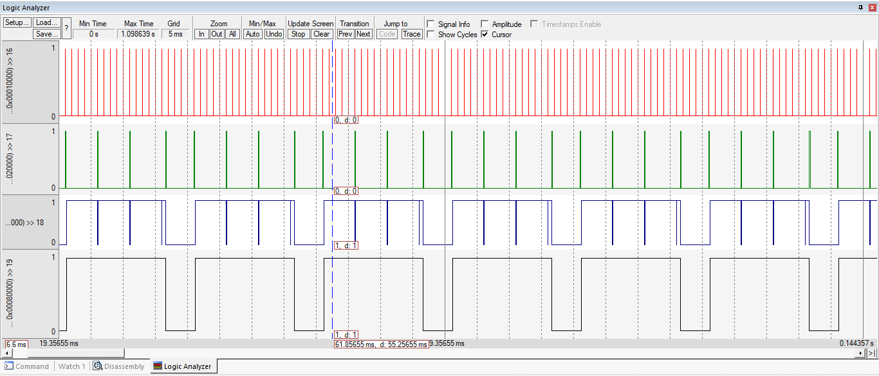

* **Calculation of execution Time of Tasks, system time and CPU Load :**

* **Comment :**
  + **In EDF Scheduler, Task1 is executed first when the deadline is nearest, but when the deadline of Task2 is nearest. Then, Task is executed first**
  + **The position of Code that Increasing deadline of idle task is not optimum position because when the CPU load increase , idle Task access CPU little time. Then, you must initial high period time of the idle task**
  + **Tick increment function , there are two change. Firstly, Task whose delay time is finished is removed from delay list, update deadline and add to EDF ready list. Secondly, check deadline of this task is less than deadline of current task if it is true , Schedular make switch between two tasks**